***Title* :**

Write shell scripts to

**a.** Rename all files in the current directory that end in “.jpg” to begin with today’s date in the following format: YYYY-MM-DD.

**b.** Delete the zero sized file

**c.** Take an input file and remove identical lines (or duplicate lines from the file)

**a.** Rename all files in the current directory that end in “.jpg” to begin with today’s date in the following format: YYYY-MM-DD.

***Program* :**

FILES=$(ls *.jpg)

DAY=$(date +%F)

for FILE in $FILES

do

mv $FILE $DAY-$FILE

done

***Output Screenshots***

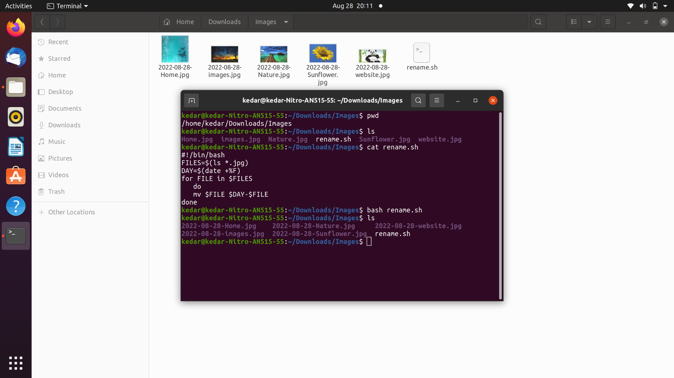

**b**. Delete the zero sized file

***Program* :**

echo "Enter Filename"

read file_name

if [ -e $file_name ]

then

echo $file_name ": File Exist"

if [ -s $file_name ]

then

echo $file_name ": File has size > 0"

else

rm $file_name

echo $file_name ": File is Deleted which has size = 0"

fi

else

echo $file_name ": File does not exist"

fi

***Output Screenshots***

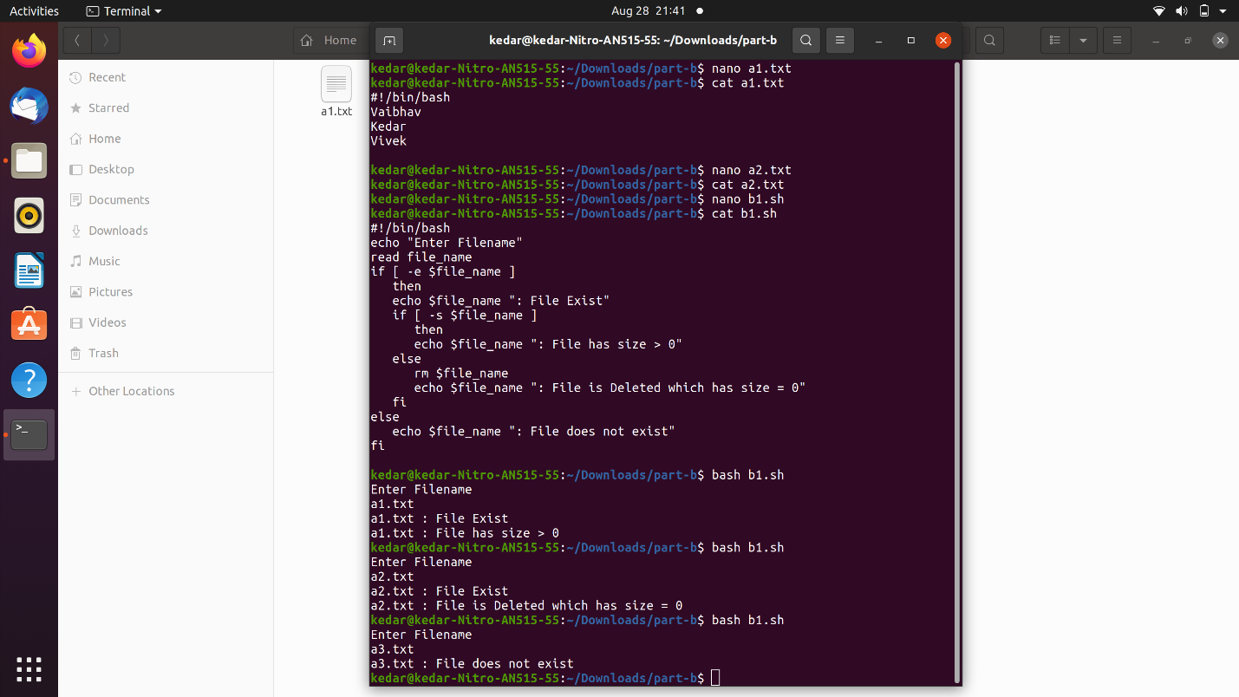

**c.** Take an input file and remove identical lines (or duplicate lines from the file)

***Program* :**

Nano a1.txt

Cat a1.txt

cat -n a1.txt > a2.txt

sort -k2 a2.txt > a3.txt

uniq -f1 a3.txt > a4.txt

sort -k1 a4.txt > a5.txt

cut -f2 a5.txt

